HA—Exploring the Reasons for Rome’s Fall

Political Cartoon | Which theory does the cartoon best relate to? Why? | Compare Ancient Rome and America today on this issue.
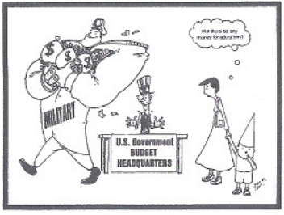 |  | Similarities:  Differences:
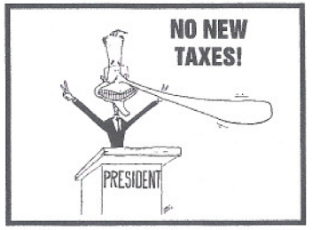 |  | Similarities:  Differences:
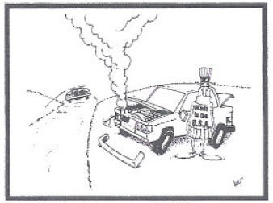 |  | Similarities:  Differences:

Political Cartoon | Which theory does the cartoon best relate to? Why? | Compare Ancient Rome and America today on this issue.
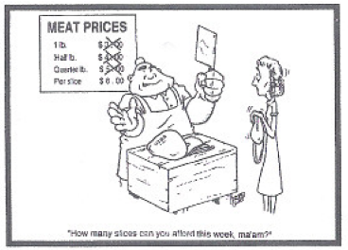 |  | Similarities:  Differences:
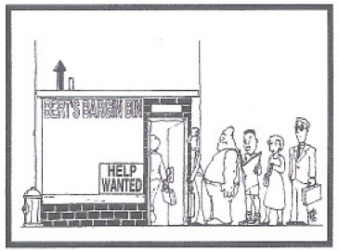 |  | Similarities:  Differences:
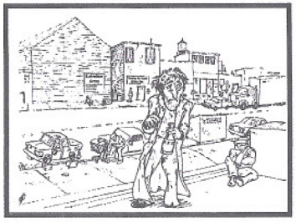 |  | Similarities:  Differences:
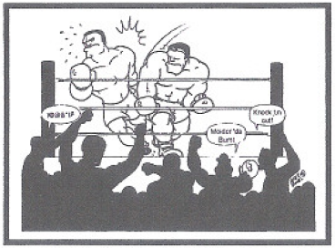 |  | Similarities:  Differences:

