SILK

[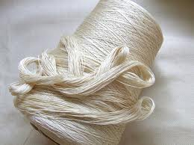](http://www.google.com/imgres?q=silk&um=1&hl=en&safe=strict&sa=N&rls=com.microsoft:en-us&rlz=1I7GPEA_en&biw=1024&bih=514&tbm=isch&tbnid=r1uXIzZeeFR3cM:&imgrefurl=http://www.ecouterre.com/ahimsa-cruelty-free-peace-silk-that-makes-for-good-karma/&docid=K9nBqWLPIperKM&imgurl=http://www.ecouterre.com/wp-content/uploads/2010/04/ahimsa-aurora-silk.jpg&w=537&h=402&ei=-aCKUJmBMaPQ2AXZ_4CgDg&zoom=1&iact=hc&vpx=572&vpy=112&dur=16&hovh=194&hovw=260&tx=150&ty=137&sig=108512104064757096296&page=3&tbnh=135&tbnw=176&start=25&ndsp=15&ved=1t:429,r:8,s:25,i:183)[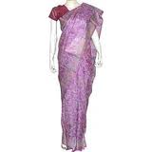](http://www.google.com/imgres?q=silk+clothing&um=1&hl=en&safe=strict&sa=N&qscrl=1&rlz=1T4AURU_enUS499&biw=1024&bih=514&tbm=isch&tbnid=GHcRk-Bgvx5XmM:&imgrefurl=http://www.kaboodle.com/reviews/silk-clothing-indian-saree-womens-dresses-party-wear&docid=Jh-QKweVYzDTkM&imgurl=http://cn1.kaboodle.com/hi/img/2/0/0/149/f/AAAAAs8mEQIAAAAAAUnz0Q.jpg%253Fv%253D1221474843000&w=200&h=200&ei=RqGKUN7uK6XQ2AWhtICoBA&zoom=1&iact=hc&vpx=482&vpy=167&dur=125&hovh=160&hovw=160&tx=89&ty=126&sig=108512104064757096296&page=3&tbnh=155&tbnw=155&start=26&ndsp=15&ved=1t:429,r:2,s:26,i:167)

[](http://www.google.com/imgres?q=silk+clothing&um=1&hl=en&safe=strict&sa=N&qscrl=1&rlz=1T4AURU_enUS499&biw=1024&bih=514&tbm=isch&tbnid=E4JPSwZYo6b4NM:&imgrefurl=http://www.thaisilkclothes.com/ladies.php&docid=EJrUA8BvGxEe5M&imgurl=http://www.thaisilkclothes.com/i/ladies.jpg&w=250&h=349&ei=RqGKUN7uK6XQ2AWhtICoBA&zoom=1&iact=hc&vpx=606&vpy=2&dur=1532&hovh=265&hovw=190&tx=120&ty=126&sig=108512104064757096296&page=1&tbnh=157&tbnw=112&start=0&ndsp=11&ved=1t:429,r:4,s:0,i:84)

PORCELAIN

[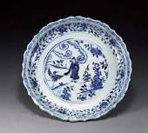](http://www.google.com/imgres?q=porcelain&um=1&hl=en&safe=strict&qscrl=1&rlz=1T4AURU_enUS499&biw=1024&bih=514&tbm=isch&tbnid=JZlIve2__4x-FM:&imgrefurl=http://202.194.48.102/englishonline/culture/chinaculture/ChinaCulture/en_madeinchina/2005-06/09/content_69512.htm&docid=_mqyS18knvCM9M&imgurl=http://202.194.48.102/englishonline/culture/chinaculture/img/2005-06/09/xinsrc_16060209092181026831.jpg&w=400&h=361&ei=lKKKUIaSK6Xa2AW39oDIAg&zoom=1&iact=rc&dur=422&sig=108512104064757096296&page=2&tbnh=141&tbnw=157&start=8&ndsp=16&ved=1t:429,r:0,s:8,i:99&tx=111&ty=87)[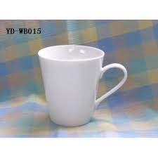](http://www.google.com/imgres?q=porcelain&um=1&hl=en&safe=strict&qscrl=1&rlz=1T4AURU_enUS499&biw=1024&bih=514&tbm=isch&tbnid=SGBvgseadBiVYM:&imgrefurl=http://www.onlyfish.org/porcelain-white-mug-ydwb015-p-188.html&docid=aTtTbHhGkqzRvM&imgurl=http://www.onlyfish.org/images/l/Porcelain-White-Mug-YD-WB015-2035.jpg&w=282&h=282&ei=lKKKUIaSK6Xa2AW39oDIAg&zoom=1&iact=rc&dur=453&sig=108512104064757096296&page=7&tbnh=154&tbnw=154&start=84&ndsp=15&ved=1t:429,r:1,s:84,i:350&tx=76&ty=103)[](http://www.google.com/imgres?q=porcelain&start=184&um=1&hl=en&safe=strict&qscrl=1&rlz=1T4AURU_enUS499&biw=1024&bih=514&tbm=isch&tbnid=wse5MDnqSdYKyM:&imgrefurl=http://www.photo-dictionary.com/phrase/6189/porcelain-dolls.html&docid=UiqNMEjFDAWa2M&imgurl=http://www.photo-dictionary.com/photofiles/list/6189/8152porcelain_dolls.jpg&w=700&h=465&ei=v6KKULi6OuqU2wX5qYHYCA&zoom=1&iact=rc&dur=0&sig=108512104064757096296&page=14&tbnh=127&tbnw=191&ndsp=15&ved=1t:429,r:11,s:184,i:320&tx=118&ty=82)[](http://www.google.com/imgres?q=porcelain+figurines&um=1&hl=en&safe=strict&qscrl=1&rlz=1T4AURU_enUS499&biw=1024&bih=514&tbm=isch&tbnid=ImM_QciUB57TKM:&imgrefurl=http://www.caleminiatures.com/lfz/index.html&docid=QILoNQQJKwOGvM&imgurl=http://www.caleminiatures.com/lfz/images/993.jpg&w=183&h=250&ei=AaOKUInFLcLs2gXej4CgDA&zoom=1&iact=rc&dur=313&sig=108512104064757096296&page=2&tbnh=163&tbnw=112&start=11&ndsp=16&ved=1t:429,r:15,s:11,i:155&tx=50&ty=130)

MECHANICAL CLOCKS

[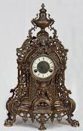](http://www.google.com/imgres?q=mechanical+clock&um=1&hl=en&safe=strict&qscrl=1&rlz=1T4AURU_enUS499&biw=1024&bih=514&tbm=isch&tbnid=2IfcS6FS-LRcKM:&imgrefurl=http://tianjinshirun.en.made-in-china.com/productimage/kMLxCPounKcI-2f0j00eBMaszGlLKqA/China-Bronze-Mechanical-Clock-SP17-3-.html&docid=yxmb6hAEpj7nyM&imgurl=http://image.made-in-china.com/2f0j00eBMaszGlLKqA/Bronze-Mechanical-Clock-SP17-3-.jpg&w=467&h=734&ei=daOKUM39K8nW2gWb6oCIBQ&zoom=1&iact=rc&dur=31&sig=108512104064757096296&page=2&tbnh=138&tbnw=79&start=9&ndsp=14&ved=1t:429,r:4,s:9,i:115&tx=61&ty=83)[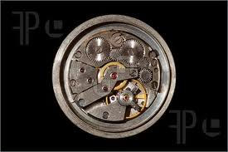](http://www.google.com/imgres?q=mechanical+clock&um=1&hl=en&safe=strict&qscrl=1&rlz=1T4AURU_enUS499&biw=1024&bih=514&tbm=isch&tbnid=evAemw3xNixetM:&imgrefurl=http://www.featurepics.com/online/MechanicalClockPictures43537.aspx&docid=e_4FjgryPOFJYM&imgurl=http://www.featurepics.com/FI/Thumb300/20060701/MechanicalClock43537.jpg&w=450&h=300&ei=daOKUM39K8nW2gWb6oCIBQ&zoom=1&iact=hc&vpx=95&vpy=92&dur=1062&hovh=183&hovw=275&tx=118&ty=119&sig=108512104064757096296&page=4&tbnh=145&tbnw=189&start=38&ndsp=15&ved=1t:429,r:0,s:38,i:197)[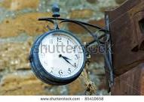](http://www.google.com/imgres?q=mechanical+clock&um=1&hl=en&safe=strict&qscrl=1&rlz=1T4AURU_enUS499&biw=1024&bih=514&tbm=isch&tbnid=VMS-skP1955fHM:&imgrefurl=http://www.shutterstock.com/pic-85410658/stock-photo-old-metal-round-mechanical-clock.html&docid=bPATINYb23lzsM&imgurl=http://image.shutterstock.com/display_pic_with_logo/54709/54709,1317063242,3/stock-photo-old-metal-round-mechanical-clock-85410658.jpg&w=450&h=321&ei=daOKUM39K8nW2gWb6oCIBQ&zoom=1&iact=rc&dur=31&sig=108512104064757096296&page=6&tbnh=135&tbnw=164&start=69&ndsp=15&ved=1t:429,r:13,s:69,i:339&tx=56&ty=69)

PRINTING

[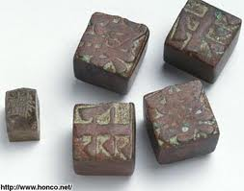](http://www.google.com/imgres?q=MOVABLE+TYPE&um=1&hl=en&safe=strict&qscrl=1&rlz=1T4AURU_enUS499&biw=1024&bih=514&tbm=isch&tbnid=AatnhUKxbvNLbM:&imgrefurl=http://stage.itp.nyu.edu/history/timeline/movabletype.html&docid=nx8Vj_1XsuXEIM&imgurl=http://stage.itp.nyu.edu/history/timeline/images/3-04.jpg&w=350&h=276&ei=waWKUOKNNcOi2AWf_IG4Dg&zoom=1&iact=hc&vpx=535&vpy=188&dur=141&hovh=199&hovw=253&tx=128&ty=200&sig=108512104064757096296&page=3&tbnh=148&tbnw=200&start=20&ndsp=12&ved=1t:429,r:6,s:20,i:158)[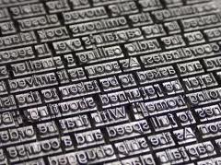](http://www.google.com/imgres?q=MOVABLE+TYPE&um=1&hl=en&safe=strict&qscrl=1&rlz=1T4AURU_enUS499&biw=1024&bih=514&tbm=isch&tbnid=TkdE_owiN0Sw3M:&imgrefurl=http://www.boiledbeans.net/2012/07/16/aux-armes-et-caetera/&docid=pCpXeTs8iItB5M&imgurl=http://www.boiledbeans.net/wp-content/uploads/2012/07/17f2d0210c52084b9ccbfdc8b613a68f.jpg&w=300&h=224&ei=waWKUOKNNcOi2AWf_IG4Dg&zoom=1&iact=rc&dur=172&sig=108512104064757096296&page=3&tbnh=146&tbnw=205&start=20&ndsp=12&ved=1t:429,r:2,s:20,i:145&tx=43&ty=45)[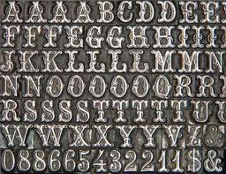](http://www.google.com/imgres?q=MOVABLE+TYPE&um=1&hl=en&safe=strict&qscrl=1&rlz=1T4AURU_enUS499&biw=1024&bih=514&tbm=isch&tbnid=mPWmX79x4V1hhM:&imgrefurl=http://www.damoselsprintersblocks.com/&docid=Ue8OitCM19NZOM&imgurl=http://www.damoselsprintersblocks.com/images/fonts2.JPG&w=332&h=256&ei=waWKUOKNNcOi2AWf_IG4Dg&zoom=1&iact=hc&vpx=537&vpy=68&dur=844&hovh=197&hovw=256&tx=100&ty=119&sig=108512104064757096296&page=4&tbnh=147&tbnw=197&start=32&ndsp=12&ved=1t:429,r:2,s:32,i:185)[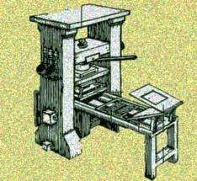](http://www.google.com/imgres?q=PRINTING+PRESS&um=1&hl=en&safe=strict&qscrl=1&rlz=1T4AURU_enUS499&biw=1024&bih=514&tbm=isch&tbnid=p4lClZR4KcJZpM:&imgrefurl=http://www.nwlink.com/~donclark/history_knowledge/printpress.html&docid=E2X3jDtWqEN2_M&imgurl=http://www.nwlink.com/~donclark/history_knowledge/printpress.jpg&w=313&h=288&ei=CqaKULiLO4S-2AXw7YFQ&zoom=1&iact=hc&vpx=262&vpy=66&dur=1891&hovh=215&hovw=234&tx=119&ty=134&sig=108512104064757096296&page=2&tbnh=150&tbnw=163&start=16&ndsp=16&ved=1t:429,r:1,s:16,i:132)

GUNPOWDER

[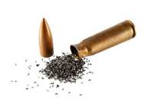](http://www.google.com/imgres?q=GUNPOWDER&um=1&hl=en&safe=strict&qscrl=1&rlz=1T4AURU_enUS499&biw=1024&bih=514&tbm=isch&tbnid=OWa8ps8fgpTJSM:&imgrefurl=http://images.yourdictionary.com/gunpowder&docid=gbMjfRPLp_sX_M&imgurl=http://images.yourdictionary.com/images/definitions/lg/gunpowder.jpg&w=377&h=250&ei=-qOKUKJ9oY7YBfiTgYgO&zoom=1&iact=rc&dur=329&sig=108512104064757096296&page=2&tbnh=121&tbnw=182&start=8&ndsp=15&ved=1t:429,r:0,s:8,i:99&tx=101&ty=80)[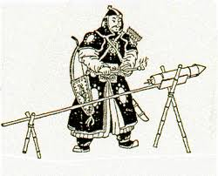](http://www.google.com/imgres?q=GUNPOWDER&um=1&hl=en&safe=strict&qscrl=1&rlz=1T4AURU_enUS499&biw=1024&bih=514&tbm=isch&tbnid=7lBa7BNXL8qJIM:&imgrefurl=http://ancienttechnology.net/gunpowder/&docid=d5vV5k075gcIQM&imgurl=http://ancienttechnology.net/wp-content/uploads/gunpowder.gif&w=414&h=334&ei=-qOKUKJ9oY7YBfiTgYgO&zoom=1&iact=hc&vpx=105&vpy=156&dur=1078&hovh=202&hovw=250&tx=127&ty=116&sig=108512104064757096296&page=2&tbnh=152&tbnw=184&start=8&ndsp=15&ved=1t:429,r:5,s:8,i:115)[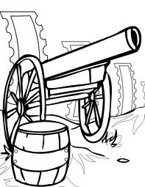](http://www.google.com/imgres?q=GUNPOWDER&um=1&hl=en&safe=strict&qscrl=1&rlz=1T4AURU_enUS499&biw=1024&bih=514&tbm=isch&tbnid=a8ukwbxLecYLhM:&imgrefurl=http://www.handipoints.com/coloring-pages/fun-facts/chinese-inventions/gun-powder.html&docid=oB86Zle7zHsAuM&imgurl=http://assets.handipoints.com/stamps/smart/chinese_inventions/gun_powder_ink.jpg&w=1275&h=1650&ei=-qOKUKJ9oY7YBfiTgYgO&zoom=1&iact=hc&vpx=271&vpy=103&dur=15&hovh=255&hovw=197&tx=123&ty=209&sig=108512104064757096296&page=7&tbnh=151&tbnw=117&start=76&ndsp=14&ved=1t:429,r:6,s:76,i:342)[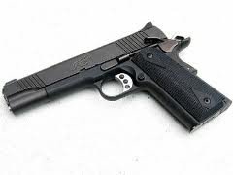](http://www.google.com/imgres?q=GUNPOWDER&um=1&hl=en&safe=strict&qscrl=1&rlz=1T4AURU_enUS499&biw=1024&bih=514&tbm=isch&tbnid=8_-0-jcQ-FSJQM:&imgrefurl=http://www.all-about-forensic-science.com/gunpowder-residue-evidence.html&docid=eSEIm_D9_ex9qM&imgurl=http://www.all-about-forensic-science.com/images/gunpowder-residue-evidence-21405437.jpg&w=300&h=225&ei=-qOKUKJ9oY7YBfiTgYgO&zoom=1&iact=rc&dur=313&sig=108512104064757096296&page=7&tbnh=143&tbnw=191&start=76&ndsp=14&ved=1t:429,r:10,s:76,i:355&tx=138&ty=78)

PAPER MONEY

[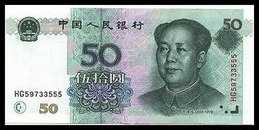](http://www.google.com/imgres?q=PAPER+MONEY+CHINESE&um=1&hl=en&safe=strict&qscrl=1&rlz=1T4AURU_enUS499&biw=1024&bih=514&tbm=isch&tbnid=FLW-1n1yJODy8M:&imgrefurl=http://www.lucylearns.com/chinese-money-paper.html&docid=d5LJ4E9jTQq9GM&imgurl=http://www.lucylearns.com/images/chinese-envelope-money-50-yuan.jpg&w=465&h=234&ei=16SKUM7dGc-_2QWth4DICA&zoom=1&iact=hc&vpx=402&vpy=116&dur=546&hovh=159&hovw=317&tx=150&ty=101&sig=108512104064757096296&page=1&tbnh=99&tbnw=197&start=0&ndsp=10&ved=1t:429,r:7,s:0,i:91)

MAGNETIC COMPASS

[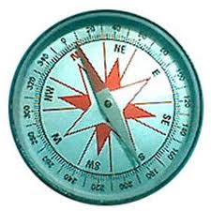](http://www.google.com/imgres?q=MAGNETIC+COMPASS&um=1&hl=en&safe=strict&qscrl=1&rlz=1T4AURU_enUS499&biw=1024&bih=514&tbm=isch&tbnid=xx0nPTWV_8crcM:&imgrefurl=http://s6kmng8.edu.glogster.com/glog-2596-magnetic-compass&docid=oB1z6bZfffQZXM&imgurl=http://edu.glogster.com/media/3/8/91/41/8914116.jpg&w=300&h=300&ei=a6WKUN2FFqLD2QWoxoFg&zoom=1&iact=hc&vpx=445&vpy=133&dur=1328&hovh=225&hovw=225&tx=119&ty=188&sig=108512104064757096296&page=1&tbnh=96&tbnw=100&start=0&ndsp=15&ved=1t:429,r:3,s:0,i:84)[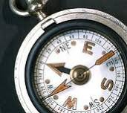](http://www.google.com/imgres?q=MAGNETIC+COMPASS&um=1&hl=en&safe=strict&qscrl=1&rlz=1T4AURU_enUS499&biw=1024&bih=514&tbm=isch&tbnid=U04XSAHR8oG2VM:&imgrefurl=http://www.namedevelopment.com/blog/archives/2006/04/northwests_compass_a_magnetic_product_name_that_po.html&docid=chToDuoD3rCvqM&imgurl=http://www.namedevelopment.com/blog/archives/Magnetic%252520Compass.jpg&w=216&h=192&ei=a6WKUN2FFqLD2QWoxoFg&zoom=1&iact=rc&dur=250&sig=108512104064757096296&page=2&tbnh=147&tbnw=153&start=15&ndsp=15&ved=1t:429,r:14,s:15,i:170&tx=54&ty=86)