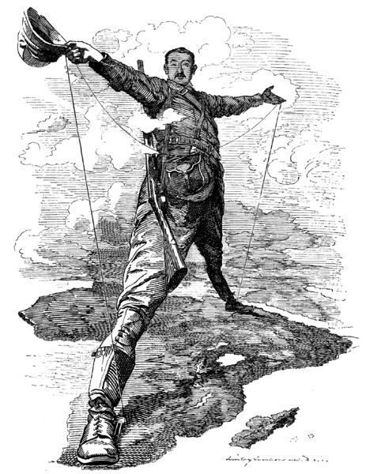

1. IMPERIALISM IN AFRICA

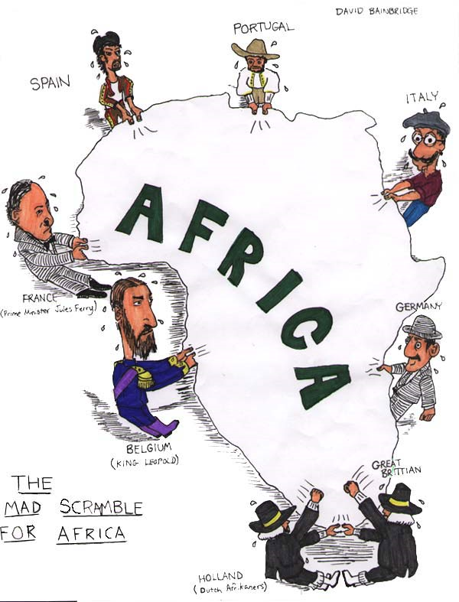

2. IMPERIALISM IN AFRICA
From village.africanpath.com
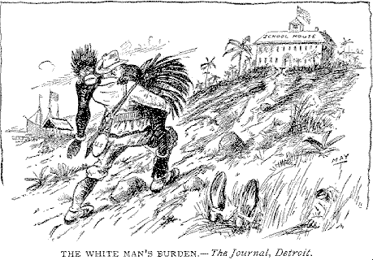
3. IMPERIALISM IN AFRICA
Cartoon in response to Rudyard Kipling’s poem, “The White Man’s Burden”
(reprinted in the Literary Digest from The Journal, Detroit, ~1899)
From http://www.assumption.edu/users/mcclymer/His130/P-H/burden/default.html
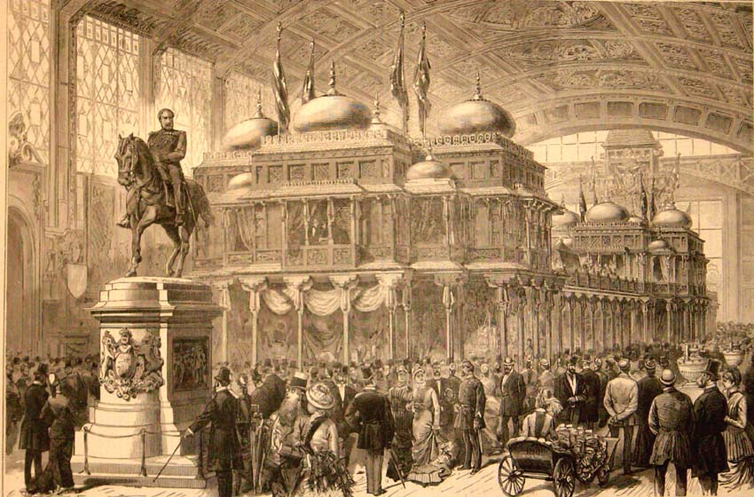

4. IMPERIALISM IN INDIA

The Paris Exhibition:
The Prince of Wales' Indian Collection in 1878. http://www.columbia.edu/itc/mealac/pritchett/00routesdata/1800_1899/dailylife_drawings/ilnviews/indiancollection.jpg.
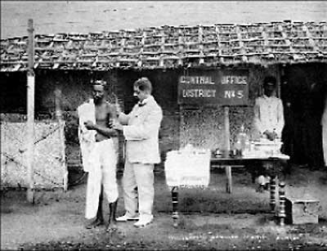

5. IMPERIALISM IN INDIA
Inoculation against plague,
Bombay, India 1897 – 1914.
From http://www.iias.nl/iiasn/25/regions/25SA1.html.
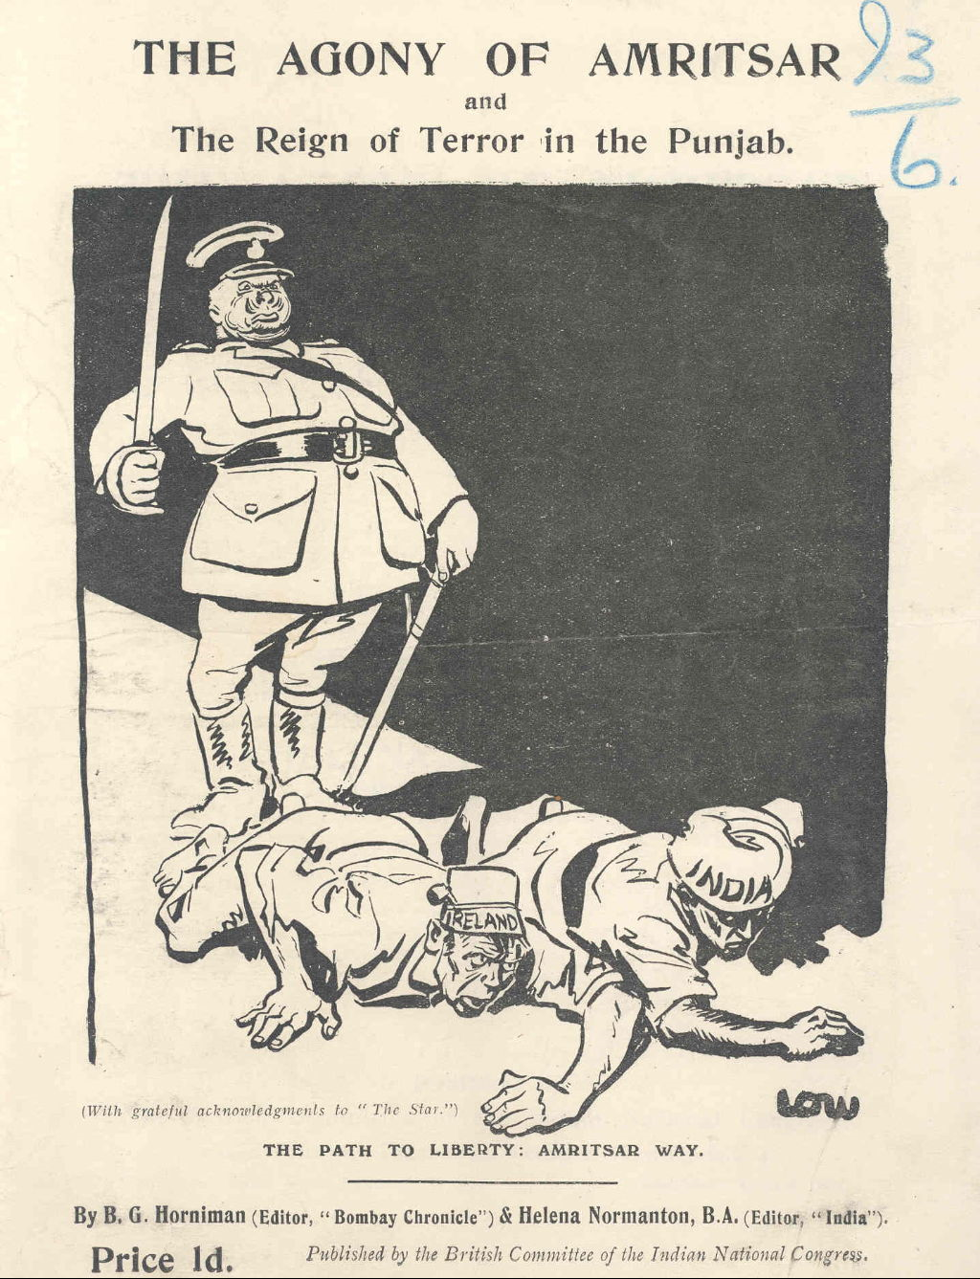
6. IMPERIALISM IN INDIA
1920. Booklet published by the British Committee of the Indian National Congress. It describes the massacre of unarmed Indian civilians at Jallianwala Bagh in Amritsar, and the events leading up to the killings.
[Included in a file on India, from the records of the Iron and Steel Trades Confederation (ISTC); document reference: MSS.36/I3]

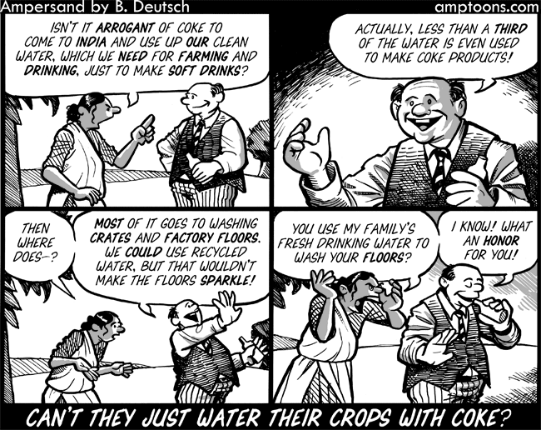

October 9th, 2008 by Barry Deutsch

7. PRESENT DAY IMPERIALISM IN INDIA?

