3-Way Venn Diagram: Revolutions
Latin American Revolutions

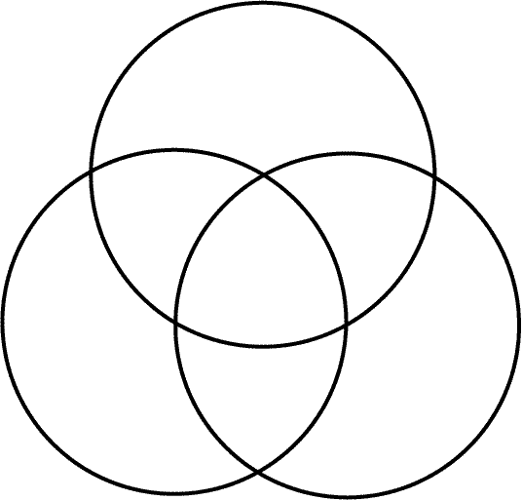

French Revolution

American
Revolution

